**Nested loop types**

**There are four types of nested loop:**

1. **Linear nested loop**
2. **Quadratic nested loop**
3. **Cubic nested loop**
4. **Dependent Quadratic nested loop**

**Firstly: Linear nested loop:**

This is a **single** for loop with a maximum value (**n**), then sequence of statements in this loop are going to execute **n** times.

**Example:**



**Secondly: Quadratic nested loop:**

This is a nested loop with **two** for loops, both have a maximum value (**n**), then sequence of statements in **most inner** loop are going to execute **n2** times.

**Example:**

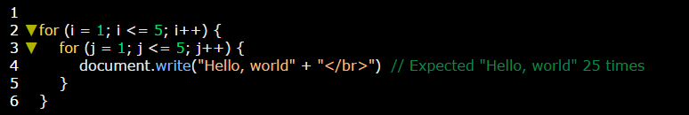

**Thirdly:** **Cubic nested loop:**

This is a nested loop with **three** for loops, all loops have a maximum value (**n**), then sequence of statements in **most inner** loop are going to execute **n2** times.

**Example:**

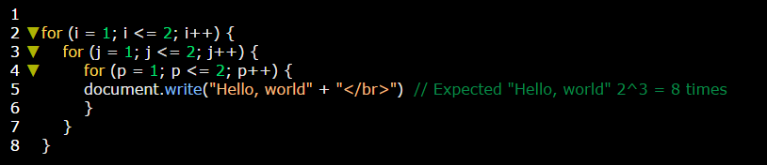

**Fourthly: Dependent Quadratic nested loop:**

This is a nested loop with **two** for loops, where the most inner loop iterations depend upon the outer value of the loop counter variable. Then sequences of statements in most inner loop are going to execute **n (n+1) /2** times.

**Example 1:**

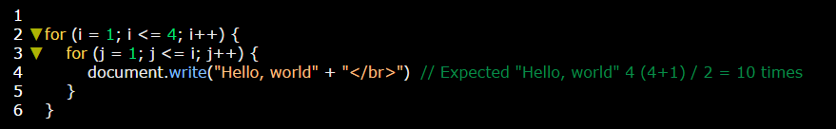

**Example 2:**

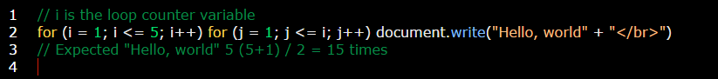

As usual you can tracing these cases in debugging mode.